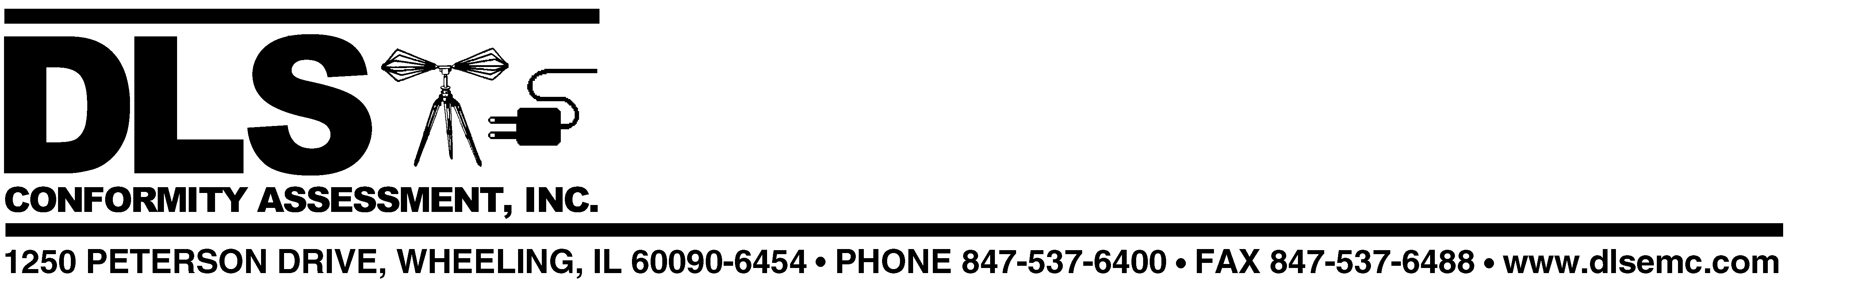

December 19, 2002

Mr. Kenn Gordon

Fullplay Media Systems, Inc.
12600 SE 38th Street Suite 150
LaGrange Park, IL 60526

Subject: Updated Quote for Evaluation, Testing and Certification (cTUVus)

Products: IMS 1.5 (preliminary model designation)

Requirements: UL 6500:1999; CSA E60065-2000

Dear Kenn:

The following estimate of costs for evaluation, testing, and certification (for US and Canada) of the above model updates the safety portion of our November 7, 2002 quote to David Dancause. A different model designation is referenced in this quote but it covers the same device as the November quote.

This quote covers only North American certification (no CE marking). For EMC, Steve Grimes has already sent a revision of the EMC quote that covers FCC certification only.

We are doing this work in cooperation with TUV Rheinland of North America, who will issue the cTUVus Mark (US NRTL and Canadian certification), based on testing and evaluation conducted by DLS Conformity Assessment.

Total Estimated Cost ……………..……………………………..$ 5600.00

This does not cover the cost of a first factory inspection by TUV Rheinland, if required. Per our phone call with Chan Wang yesterday, a first factory inspection may not be necessary.

This estimated cost includes testing and certification activities for all both of the standards cited above. It also includes reasonable consulting time as necessary to identify and correct any non-compliant items requiring modification in order to meet the standards. If additional or repeated testing is required as a result of modifications made during the course of the project, additional cost may be incurred; we would of course advise you in advance of applying any additional charges.

Costs are estimated; all final billing will be based on the time spent on your behalf. * This estimate is valid for 90 days after which prices are subject to change without notice.

We’ll need the following items in order to initiate the program:

- Verification that this new unit uses the same laser as that in the UL Listed LVS 1000. If it does not use the same scanner and circuitry, we’ll need specifications for the one you are using.
- Schematic(s) for the new version
- Specifications for the inverter used to supply voltage for backlighting of the LCD display, or a contact name and phone number of the rep that can supply this information.
- Identification of the enclosure plastic material (material manufacturer, type and grade designation). As discussed with you previously, molded enclosure samples can be supplied for mechanical testing after electrical testing has been completed.

In order to simplify paperwork for you, a single P.O. can be issued to DLS Conformity Assessment for the above amount. We will then invoice you for both TUV Rheinland and DLS charges.

Please feel free to contact me if you have questions or concerns regarding the above. We look forward to working with you again.

Best Regards,
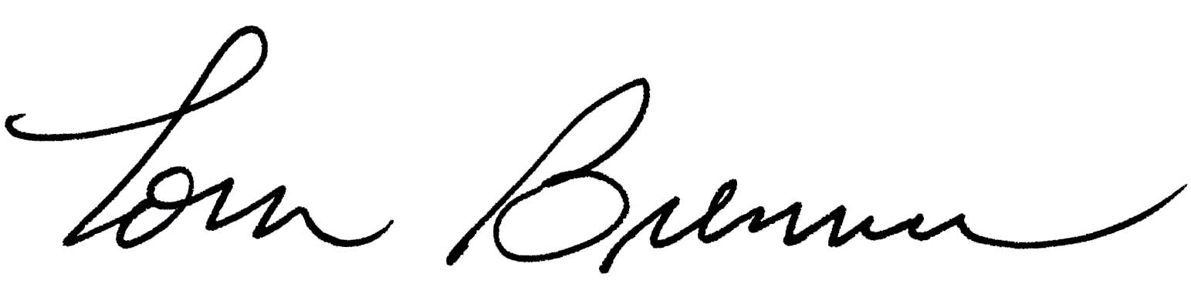
Tom Brenner

Manager – Product Safety
D.L.S. Conformity Assessment, Inc.
tbrenner@dlsemc.com

*SUBJECT TO THE ATTACHED TERMS AND CONDITIONS. The liability of D.L.S. Electronic Systems, Inc. with respect to the goods and services charged for herein shall in no event exceed the paid amount of this notice.

D.L.S. Conformity Assessment, Inc. is a wholly owned subsidiary of D.L.S. Electronic Systems, Inc.
All Orders are accepted and all reports and certificates issued subject to the General Conditions for Inspection and Testing Services (copy available upon request).

